Srs 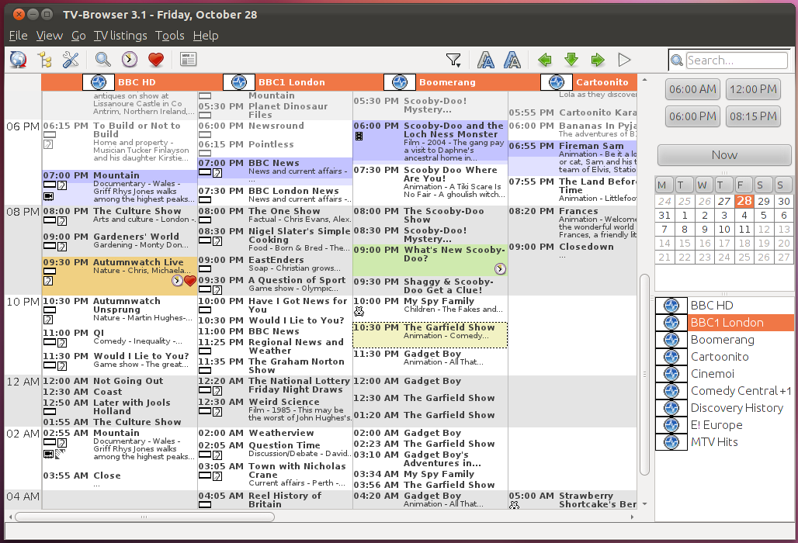

|  |  |
| --- | --- |
| **Use Case** | **Edit Image** |
| Description | Enables the user to edit the description and tags for their uploaded images. |
| Primary Actor | User |
| Stakeholders and Interest | User - Can modify the details of the image after it has been uploaded |
| Preconditions | User must be logged in  User must have at least one image in the database |
| Postconditions | Image details will be updated to reflect the new information |
| Triggers | User wants to change the information about an image |
| Basic Flow | 1. User clicks on the Personal Photo Album Web Application on their browser, which directs them to the homepage of their personal album 2. User selects an image 3. The image will be displayed on a new page 4. User clicks the Edit Tags button    1. User can add new tags to the image    2. User can delete existing tags from the image    3. User clicks the Save Changes button       1. Database is updated with the new tags    4. Image is displayed with edited tags 5. User clicks the Edit Description button    1. Description becomes editable, retains current text    2. User changes the image’s description    3. User clicks the Save Changes button       1. Database is updated with the new description    4. Image is displayed with edited description |
| Alternate Flow | 4c, 5c. User clicks Cancel button  6. Page refreshes showing old page without any changes |
| Business Rules |  |
| Assumptions |  |
| Linked Cases | * Add tags |
| Technology, Data Variations and Special Requirements |  |
| Open Issues | 1. Videos will be an additional extra if there is enough time available |